IPL SQL ANALYSIS QUERIES OUTPUT

- SELECT TOP 5 MATCHES
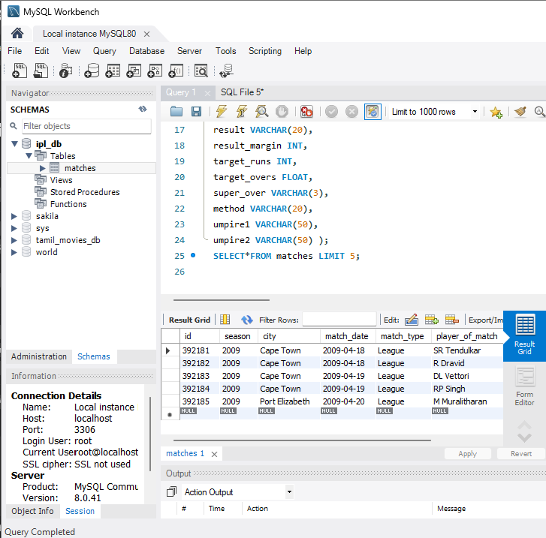

- COUNT OF TOTAL MATCHES
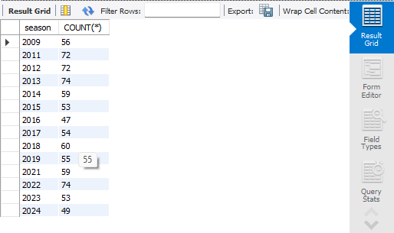

- TOP 5 PLAYER OF MATCH
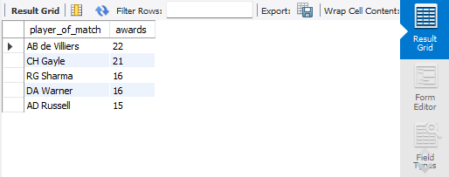

- TOP 5 TOTAL NUMBER OF WINNING MATCHES
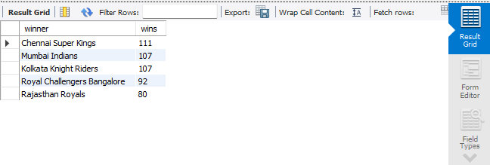

- COUNT OF MATCHES AT CHENNAI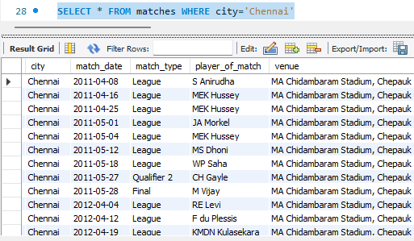

- TOSS STATS

